**DEPARTMENT OF COMPUTER & SOFTWARE ENGINEERING**

**COLLEGE OF E&ME, NUST, RAWALPINDI**

**Subject Name**

**Digital Image Processing**

**Lab Number**

**5**

**SUBMITTED TO:**

**Dr. Asad Khan**

**LE Sundas Ashraf**

**SUBMITTED BY:**

**Student Name**

1. Wahaaj Nasir

**Reg#413238**

**DE- 44 Dept C&SE**

**Objectives:**

Filtering on Images and Histogram Calculations

**Related Topic/Chapter in theory class:**

Spatial Filtering

**Hardware/Software required:**

Hardware: PC

Software Tool: Pycharm

**Task 1:**

**Lab Task 1:**

**Apply the following filters with size 3, 15 and 31 on images Fig01.tif and Fig02.tif:**

**• Median**

**• Min**

**• Max**

**Solution:**

import numpy as np  
import cv2 as cv  
  
def padding(pad, orig):  
 rows, cols = orig.shape  
 padded_arr = np.ones((rows+ 2 * pad, cols+ 2 * pad), dtype = np.uint8)*255  
  
 for i in range(rows):  
 for j in range(cols):  
 padded_arr[i+pad][j+pad] = orig[i][j]  
  
 return padded_arr  
  
def remove_padding(padded_img, pad):  
 rows, cols = padded_img.shape  
 return padded_img[pad:rows-pad, pad:cols-pad]  
  
def filter_min(image, filter_size):  
 pad = filter_size//2  
 rows, cols = image.shape  
 filtered_img = np.zeros((rows, cols), dtype = np.uint8)  
  
 padded_img = padding(pad, filtered_img)  
 for i in range(pad, rows-pad):  
 for j in range(pad, cols-pad):  
 sub_img = image[i-pad:i+pad+1, j-pad:j+pad+1]  
 sub_img_val = np.min(sub_img)  
 padded_img[i][j] = sub_img_val  
  
 filtered_img = remove_padding(padded_img, pad)  
  
 return filtered_img  
  
def filter_max(image, filter_size):  
 pad = filter_size//2  
 rows, cols = image.shape  
 filtered_img = np.zeros((rows, cols), dtype = np.uint8)  
  
 padded_img = padding(pad, filtered_img)  
 for i in range(pad, rows-pad):  
 for j in range(pad, cols-pad):  
 sub_img = image[i-pad:i+pad+1, j-pad:j+pad+1]  
 sub_img_val = np.max(sub_img)  
 padded_img[i][j] = sub_img_val  
  
 filtered_img = remove_padding(padded_img, pad)  
  
 return filtered_img  
  
def filter_median(image, filter_size):  
 pad = filter_size//2  
 rows, cols = image.shape  
 filtered_img = np.zeros((rows, cols), dtype = np.uint8)  
  
 padded_img = padding(pad, filtered_img)  
 for i in range(pad, rows-pad):  
 for j in range(pad, cols-pad):  
 sub_img = image[i-pad:i+pad+1, j-pad:j+pad+1]  
 sub_img_val = np.median(sub_img)  
 padded_img[i][j] = sub_img_val  
  
 filtered_img = remove_padding(padded_img, pad)  
  
 return filtered_img  
  
*#-----------------  
# Main*image = cv.imread("D:/Uni/Semester 6/DIP/Self/Lab/Lab 5/Lab 5/Fig01.tif", 0)  
  
max_img_3 = filter_max(image, 3)  
min_img_3 = filter_min(image, 3)  
median_img_3 = filter_median(image, 3)  
  
max_img_15 = filter_max(image, 15)  
min_img_15 = filter_min(image, 15)  
median_img_15 = filter_median(image, 15)  
  
max_img_31 = filter_max(image, 31)  
min_img_31 = filter_min(image, 31)  
median_img_31 = filter_median(image, 31)  
  
  
cv.imshow('Original', image)  
cv.imshow('Max Filter', max_img_3)  
cv.imshow('Min Filter', min_img_3)  
cv.imshow('Median Filter', median_img_3)  
cv.waitKey()  
  
cv.imshow('Original', image)  
cv.imshow('Max Filter', max_img_15)  
cv.imshow('Min Filter', min_img_15)  
cv.imshow('Median Filter', median_img_15)  
cv.waitKey()  
  
cv.imshow('Original', image)  
cv.imshow('Max Filter', max_img_31)  
cv.imshow('Min Filter', min_img_31)  
cv.imshow('Median Filter', median_img_31)  
cv.waitKey()

**Output:**

**3x3**

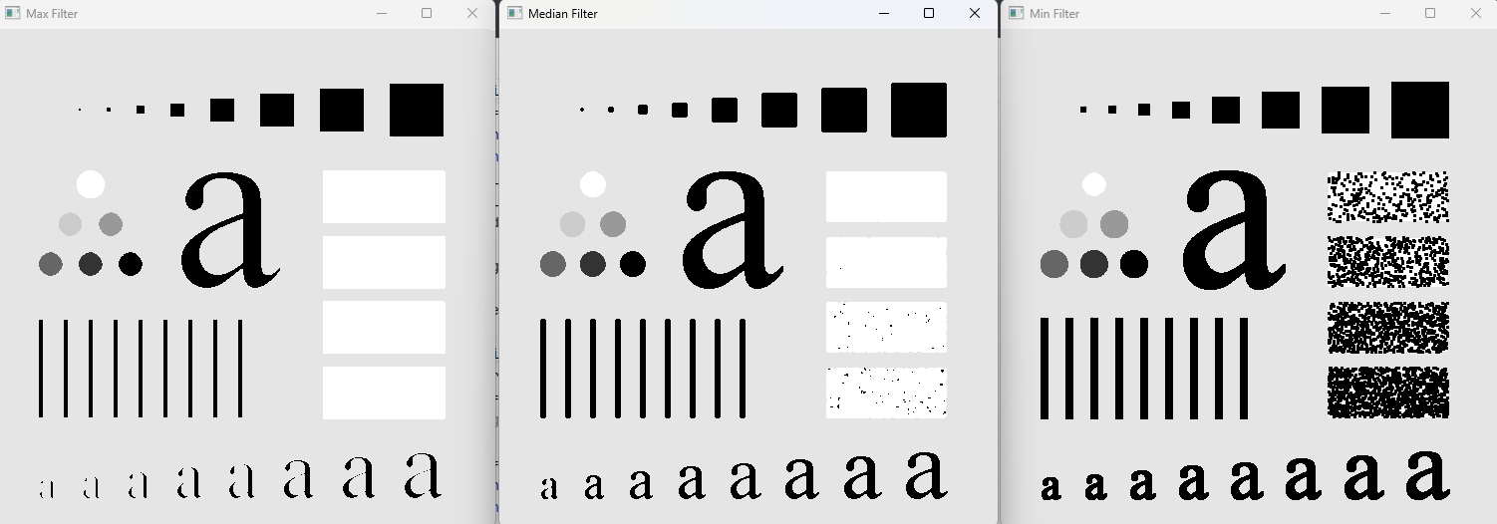

**Max Median Min**

**15x15**

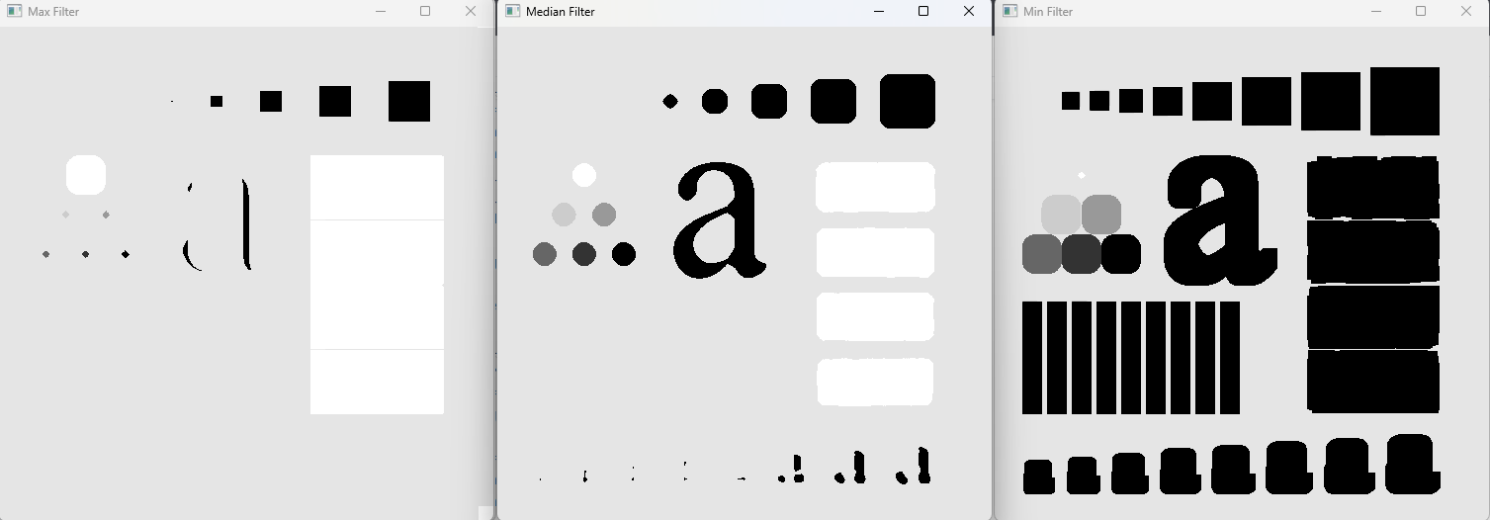

**Max Median Min**

**31x31**

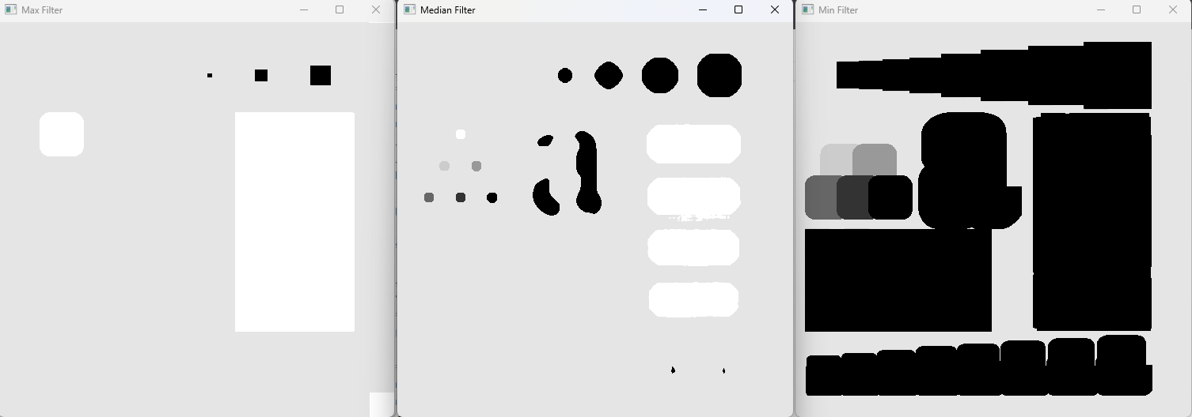

**Max Median Min**

**Task 2:**

**Apply Horizontal Sobel and Vertical Sobel separately on the Fig03.tif. Display the results. Then add the images obtained by Horizontal Sobel and Vertical Sobel together and display the resultant images with all the edges.**

**Solution**

import numpy as np  
import cv2 as cv  
  
def padding(pad, orig):  
 rows, cols = orig.shape  
 padded_arr = np.ones((rows+ 2 * pad, cols+ 2 * pad), dtype = np.uint8)*255  
  
 for i in range(rows):  
 for j in range(cols):  
 padded_arr[i+pad][j+pad] = orig[i][j]  
  
 return padded_arr  
  
def remove_padding(padded_img, pad):  
 rows, cols = padded_img.shape  
 return padded_img[pad:rows-pad, pad:cols-pad]  
  
def filter_sobel(image, filter_size):  
 pad = filter_size//2  
 rows, cols = image.shape  
 mag_img = np.zeros((rows, cols), dtype = np.float32)  
 phase_img = np.zeros((rows, cols), dtype=np.float32)  
  
 filter_x = np.zeros((3, 3), dtype=int)  
 filter_y = np.zeros((3, 3), dtype=int)  
  
 *# Filter_X* filter_x[0][0] = -1  
 filter_x[0][1] = -2  
 filter_x[0][2] = -1  
 filter_x[1][0:3] = 0  
 filter_x[2][0] = 1  
 filter_x[2][1] = 2  
 filter_x[2][2] = 1  
  
 *# Filter_Y* filter_y[0][0] = -1  
 filter_y[0:3][1] = 0  
 filter_y[0][2] = 1  
 filter_y[1][0] = -2  
 filter_y[1][2] = 2  
 filter_y[2][0] = -1  
 filter_y[2][2] = 1  
  
 for i in range(pad, rows-pad):  
 for j in range(pad, cols-pad):  
 sub_img = image[i-pad:i+pad+1, j-pad:j+pad+1]  
 sobel_x = np.sum(np.multiply(sub_img, filter_x))  
 sobel_y = np.sum(np.multiply(sub_img, filter_y))  
 mag = np.sqrt(sobel_x**2 + sobel_y**2)  
 phase = np.arctan2(sobel_y, sobel_x)  
 mag_img[i][j] = mag  
 phase_img[i][j] = phase  
  
 mag_max = np.max(mag_img)  
 mag_min = np.min(mag_img)  
 mag_img = ((mag_img - mag_min)/(mag_max - mag_min)) *255  
 phase_img = ((phase_img - np.min(phase_img))/(np.max(phase_img) - np.min(phase_img))) *255  
  
 mag_img = mag_img.astype(np.uint8)  
 phase_img = phase_img.astype(np.uint8)  
  
 return mag_img, phase_img  
  
  
*#---------------------  
# Main*image = cv.imread("D:/Uni/Semester 6/DIP/Self/Lab/Lab 5/Lab 5/Fig03.tif", 0)  
  
cv.imshow('Original Image', image)  
cv.waitKey()  
  
mag_img, phase_img = filter_sobel(image, 3)  
  
cv.imshow('Magnitude Image', mag_img)  
cv.imshow('Phase Image', phase_img)  
cv.waitKey()

**Output:**

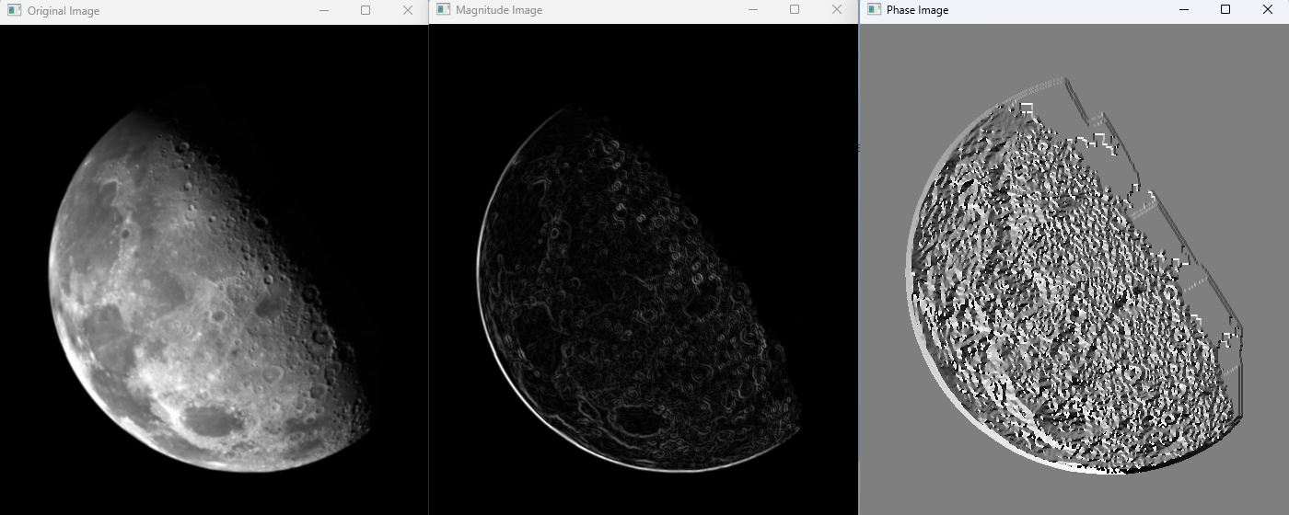

**Task 3:**

**Apply the following Laplacian mask to image Fig03.tif. Then add the filtered image to the**

**original image for a sharpening effect.**

**Solution**

import numpy as np  
import cv2 as cv  
  
def padding(pad, orig):  
 rows, cols = orig.shape  
 padded_arr = np.ones((rows+ 2 * pad, cols+ 2 * pad), dtype = np.uint8)*255  
  
 for i in range(rows):  
 for j in range(cols):  
 padded_arr[i+pad][j+pad] = orig[i][j]  
  
 return padded_arr  
  
def remove_padding(padded_img, pad):  
 rows, cols = padded_img.shape  
 return padded_img[pad:rows-pad, pad:cols-pad]  
  
def filter_laplace(image, filter_size):  
 pad = filter_size//2  
 rows, cols = image.shape  
 laplace_filter = np.array([[-1, -1, -1], [-1, 8, -1], [-1, -1 , -1]], dtype = int)  
 laplace_img = np.zeros((rows, cols), dtype = np.float32)  
  
 padded_img = padding(pad, image)  
 for i in range(pad, rows-pad):  
 for j in range(pad, cols-pad):  
 sub_img = padded_img[i-pad:i+pad+1, j-pad:j+pad+1]  
 value = np.sum(np.multiply(sub_img, laplace_filter))  
 laplace_img[i][j] = value  
  
 laplace_img = np.clip(image.astype(np.int16) + laplace_img, 0, 255)  
 laplace_img = laplace_img.astype(np.uint8)  
  
 return laplace_img  
  
  
*#---------------------  
# Main*image = cv.imread("D:/Uni/Semester 6/DIP/Self/Lab/Lab 5/Lab 5/Fig03.tif", 0)  
  
cv.imshow('Original Image', image)  
cv.waitKey()  
  
laplace = filter_laplace(image, 3)  
cv.imshow('Laplace', laplace)  
cv.waitKey()

**Output:**

